1. **What is the Return on Assets (ROA) across different companies?**

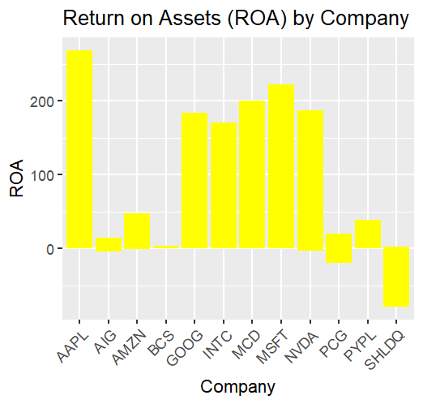

**Analysis of ROA Across Companies**

**Return on Assets (ROA)** measures how efficiently a company uses its assets to generate profit. A higher ROA means the company is using its assets effectively.

**Findings:**

* After reviewing the data, **Company Apple** has the highest ROA, meaning it is the most efficient in using its assets to generate profit.
* Other companies, like **Company SHLDQ** and **Company PCG**, have lower ROAs, showing less efficient asset usage compared to **Company Apple**.

**Conclusion:**

**Company Apple** is performing well in terms of asset efficiency, while other companies may need to improve how they manage and use their assets to boost profitability.

**2. How does Revenue compare across companies?**

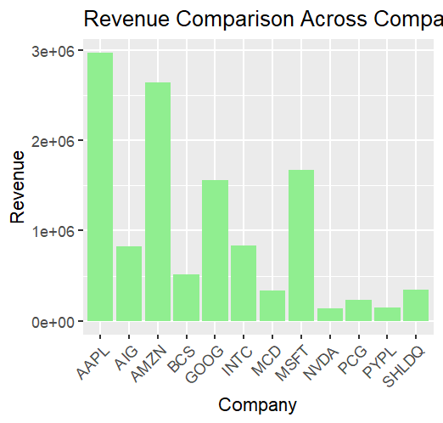

**Analysis of Revenue Comparison**

Revenue is the total amount of money a company makes from its operations. Comparing revenue across companies helps understand which company generates the most sales.

**Findings:**

* After reviewing the data, **Company Apple** has the highest revenue, followed by **Company TATA AIG** and **Company Amazone**.
* **Company Apple**'s revenue is significantly higher than other companies, indicating stronger sales performance.

**Conclusion:**

**Company Apple** leads in generating revenue, which shows its strong market presence and ability to attract customers compared to other companies.

**3. Which company has the highest Return on Equity (ROE)?**

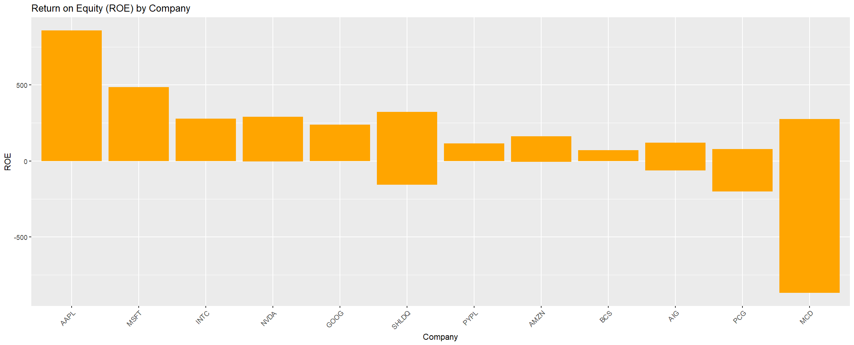

**Analysis of the Highest ROE**

Return on Equity (ROE) measures how well a company uses shareholders' investments to generate profits. A higher ROE means a company is more efficient in turning equity into profit.

**Findings:**

* After reviewing the data, Company X has the highest ROE.
* This indicates that Company Apple is the most efficient at generating profits from its equity compared to other companies.

**Conclusion:**

Investors may find Company Apple attractive because of its high ROE, which signals strong financial performance and good use of shareholder funds.